Establish a cardiac emergency response plan that includes your AED.
Creating your own detailed plan is recommended. Should you need assistance,
Project ADAM can provide you with several plan templates.

Have a response team of 5-10 people, or 10% of staff, at opposite ends of the campus to ensure full coverage in case of emergency.
The team/staff should be CPR certified or they can receive annual hands-only CPR and automated external defibrillator (AED) training with observed compression practice. For schools located in the DFW Metroplex, contact Project ADAM to schedule a FREE training today.

For schools located in the DFW Metroplex, schedule an AED drill with Project ADAM to test your emergency response.
Project ADAM can bring in a mannequin and an AED trainer for team members to practice compressions and apply the AED pads in a relaxed setting. The drills takes less than 10 minutes with minimal disruption during regular school hours.
Click into this text box and then insert an image. You can widen the text box some if needed.
Place your school’s AED(s) no more than 3 minutes away from the farthest part of campus.
For every minute without defibrillation from an AED, survival decreases by 10%. Ask Project ADAM for an AED site assessment to help choose the best location(s) for your AED(s).

Ensure that ALL staff members are aware of your school’s emergency response plan and are ready to act.
Always be prepared. Having a trained team and a staff that knows your school’s plan are critical to survival. Project ADAM is here to help you prepare and can answer any of your questions
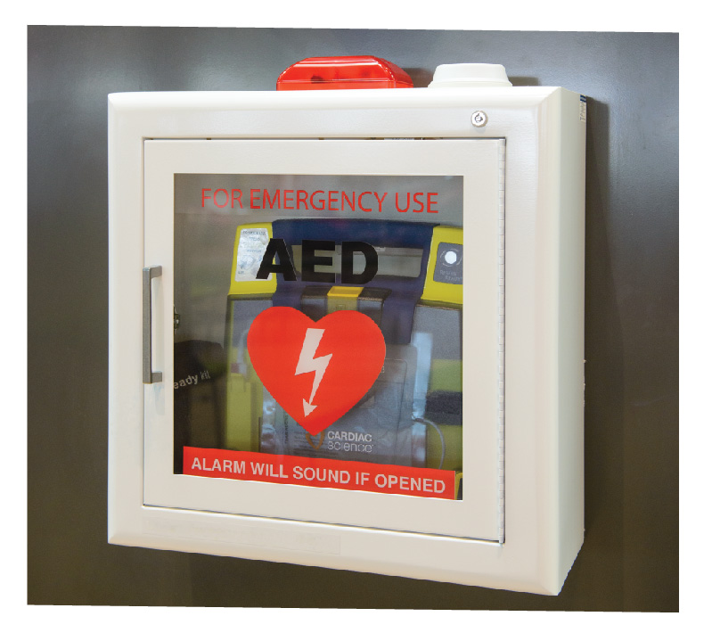
My child, _________________________, has been diagnosed with _________________________________.
Here’s what YOU can do to help:

