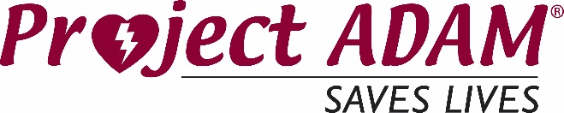
Criteria for Project ADAM affiliate programs
** If there is an existing affiliate in the area, the need and option for another affiliate will be explored. Before moving forward, consideration will be given to ensure organizations can work together to maintain a streamlined approach to supporting the community and will have the ability to collaborate effectively when necessary.
** If your organization does not fit the criteria, consider partnering with an existing affiliate to support/expand Project ADAM’s work. Please complete the interest form to further explore this option.

Affiliate Organization
- A healthcare organization, children’s hospital, medical school or academic medical center that has a pediatric focus or has direct partnership with a pediatric center.
- An interest and passion to provide a long-term and sustainable program to empower and prepare schools and communities to prepare for sudden cardiac arrest in both youth and adults.

Program Leadership
- Provides a program coordinator, who has access to a pediatric center/heart center, and is able to connect with coordinators of the other national affiliates. The program coordinator is the lead contact person and expert for schools and other organizations interested in implementing Project ADAM programming.
- It is encouraged that program medical direction is provided by a pediatric physician but other options can be explored based on expertise and passion around the prevention and preparedness of sudden cardiac arrest.

National Involvement
- Attendance at the Project ADAM annual national meeting.
- Involvement with national working committees, Education, Advocacy, Publications & Growth.
Additional keys to success to explore:
- If there is an existing Project ADAM affiliate in your state, please collaborate with existing affiliates on the educational service model supporting programming in your local communities. A streamlined model across sites is critical to best serving your state’s needs.
- Having a plan in place for the program coordinator role is critical to the success of our affiliates. We do not require funding/full FTE to be in place upfront, but kindly request to review a thoughtful plan to build up to a portion of FTE dedicated to Project ADAM’s ongoing work.

