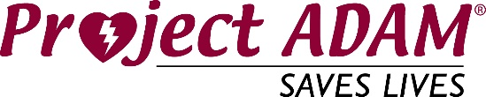

Program Coordinator Checklist

General Responsibilities
  - Serves as an advocate/expert resource for the mission to support implementation of CPR/AED programs in partnership with program Medical Director.
  - Facilitates day to day communication with partner schools.
  - Deliverers school-based and community educational workshops and/or training on Project ADAM and Heart Safe Schools.
  - Assists school systems with problem solving barriers that exist in their Cardiac Emergency preparedness programs.
  - Coaches and assists schools to achieve Heart Safe School criteria through Project ADAM.
  - Logs communication and tracks Heart Safe School data from partner schools.
  - Attends monthly Project ADAM program coordinator meetings and the annual national meeting.
  - Assists with philanthropic efforts to obtain funding for local Project ADAM efforts.
  - Participates in Project ADAM national committees.
  - Collaborates with Project ADAM affiliates and other program coordinators.
  - Promotes and maintains collaborative relationships with key program stakeholders.

Program Coordinator – expertise/education in one or more of the following areas recommended
- Nursing
- Healthcare Background
- Public / Community Health Education
- Emergency Medical Services
- Business/program development

