Project ADAM All Staff Orientation

Introduction:
This is a script that can be modified for any school. This presentation lasts approximately 20 minutes but feel free to modify it to fit your needs. If you’re short on time, many schools will omit/modify one or more videos, sections and/or email links to staff. The important part is to cover the warning signs, recognition, communication procedures, staff roles and your school’s individual cardiac emergency response plan, so everyone is aware of who is on the team, what the plan is and what to do in the event a cardiac emergency occurs. You will need a computer, internet access, copies of your school’s cardiac emergency response plan, a projector and projector screen (if needed and/or available). This training is best done at an ALL staff meeting.
Frequency:
Project ADAM recommends this staff orientation is conducted at least once annually and repeated/ shared with any new staff.

Learning Objectives:
- Introduce Project ADAM’s role in schools
- Identify Sudden Cardiac Arrest (SCA)
- Introduce staff to your school’s particular Automated External Defibrillator (AED) and location
- Introduce members of the school’s Cardiac Emergency Response Team
- Review the school Cardiac Emergency Response Plan and AED Drill process

Project ADAM Training Videos:
All school staff should know the signs of a SCA and how to take action. www.projectadam.com/Heartsafeschools

Chapter 1: The Adam in Project ADAM {2:40}
Chapter 2: Understanding Sudden Cardiac Arrest {5:36}

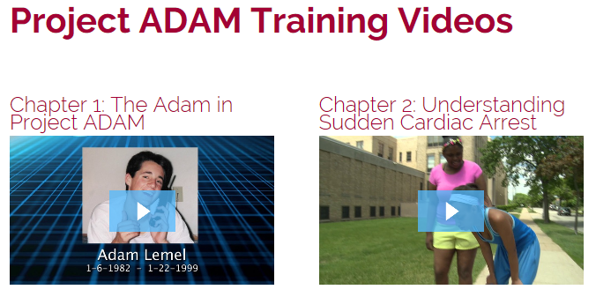

Sample Script to Meet Objectives:
We have been working towards becoming/are a designated Heart Safe School with Project ADAM. Project ADAM takes its name after Adam Lemel, a 17-year-old Wisconsin high school student who collapsed and died while playing basketball.
Being a Heart Safe School with Project ADAM means we will experience annual Project ADAM all staff training as well as participate in ongoing cardiac emergency response (AED) drills. The AED drill is an exercise that helps us to measure our preparedness and identify opportunities for improvement in our process.
To begin, we’re going to watch two short videos that cover why our school is partnering with Project ADAM, define Sudden Cardiac Arrest (SCA) and what a good response looks like:
Watch Chapter 1: The Adam in Project ADAM {2:40}

Watch Chapter 2: Understanding Sudden Cardiac Arrest {5:36}
It’s important to understand that there is a general plan that every school should follow. The Cardiac Chain of Survival is simple and easy to remember:
1. Early recognition of SCA
2. Early call to 9-1-1
3. Early CPR
4. Early AED
5. Early Advanced Care

There’s usually not much warning with a SCA. Often these victims are the picture of health, out for their daily run or in the middle of a ball game when they suddenly drop.

Signs of SCA can include one or more of the following:
- Not moving, unresponsive or unconscious
- Not breathing normally (i.e., may have irregular breathing, gasping, gurgling or may not be breathing at all)
- Seizure or convulsion-like activity

Those who collapse shortly after being struck in the chest by a firm projectile/direct hit may have SCA from commotio cordis.

AED stands for Automated External Defibrillator. The AED(s) at our school is/are located ______________. These devices should be stored in an unlocked case. Most AED cases have an alarm. The alarm is not connected to EMS but is your notification that the device has been taken from the case. If the AED is retrieved in an emergency, we recommend letting the alarm sound until the team has responded to the scene.
AED Demonstration:
The AED is very simple to use. Demonstrate briefly how to turn the school AED on, where the pads for adult and children are located, proper placement of the pads, safety precautions and what’s included in the first responder kit near/attached to the AED.
The AED cannot hurt anyone and will only deliver a shock if necessary. It should not be feared. The AED will walk you through the steps.
Our School’s Team and Response:
We have established a Cardiac Emergency Response Team and a plan in the event of a SCA. Part of this plan is that the entire staff is aware of the procedure. Ask response team to stand. These people have agreed to serve as our school response team. They have been trained in CPR and AED use (or they will be shortly!) and will come to your aid when needed. Whether or not you are on the “team,” you are responsible in some way.
At this point, describe your school’s specific response procedure including items such as:
- Identified code name (what they’ll hear on the overhead page to identify a cardiac emergency, i.e. Code AED)
- Method of communication (for example, do they call the front office on the phone, hit the panic button, send a student to the front office to activate the emergency response, etc.)
- Who waits with the victim and who will go outside to wait and direct EMS to the scene
If you are not a team member, keep your students in their classroom and stay out of the hallways. If your classroom is near a team member, make sure their students are supervised so the team member can attend to the victim. All staff should make every effort to protect the privacy and dignity of the victim, while also protecting their students from the trauma of such an incident.

All other personnel should clear the area and should take care to keep students away from the victim and out of the hallways. When EMS has left the premises, the front office should notify the staff with an overhead announcement: “Staff may resume normal activities at this time.”

Conducting a Drill:

Next, explain to all staff the frequency and process for conducting Cardiac Emergency Response (AED) Drills in your school (i.e. our drill will be sometime in __________). Do NOT give them an exact date, just a general timeframe.

Are there any questions? Does everyone understand our plan? Remember, we could do the AED drill in front of your classroom and pull you to participate, so it’s important you understand the process!

